

# AMERICAN INTERNATIONAL UNIVERSITY- BANGLADESH (AIUB)

**Introduction to Electrical Circuit**

**FALL 2023-2024**

**Section: L, Group: 07**

# LAB REPORT ON

# *Verification of Kirchoff’s Voltage Law (KVL) and Kirchoff’s Current Law (KCL)*

# Supervised By

## MD. SHAHARIAR PARVEZ

|  |  |
| --- | --- |
| **Name** | **ID** |
| **1.MD. Abdullah** | **22-48065-2** |
| **2.Azmir Islam Kafi** | **22-47981-2** |
| **3.Mohammad Ansar Uddin** | **22-47975-2** |
| **4.Chinmoy Guha** | **22-48056-2** |
| **5.Suvra Chakraborty** | **22-48067-2** |

### 

***Abstract:***

Kirchhoff's circuit laws, introduced by Gustav Kirchhoff in 1845, are two fundamental principles that pertain to current and voltage (potential difference) within electrical circuits. These laws are often referred to as Kirchhoff's rules or Kirchhoff's laws. They provided a generalized framework building upon the earlier work of Georg Ohm and predated Maxwell's contributions. Widely applied in the field of electrical engineering, the objectives of this experiment are as follows:

* To gain practical insight into Kirchhoff's Voltage Law (KVL) and Kirchhoff's Current Law (KCL).
* To validate experimentally obtained values against calculated values.

***Apparatus:***

1. Resistors
2. Connecting wire
3. Trainer Board
4. AVO meter or Multimeter
5. DC source

***Circuit Diagram:*** 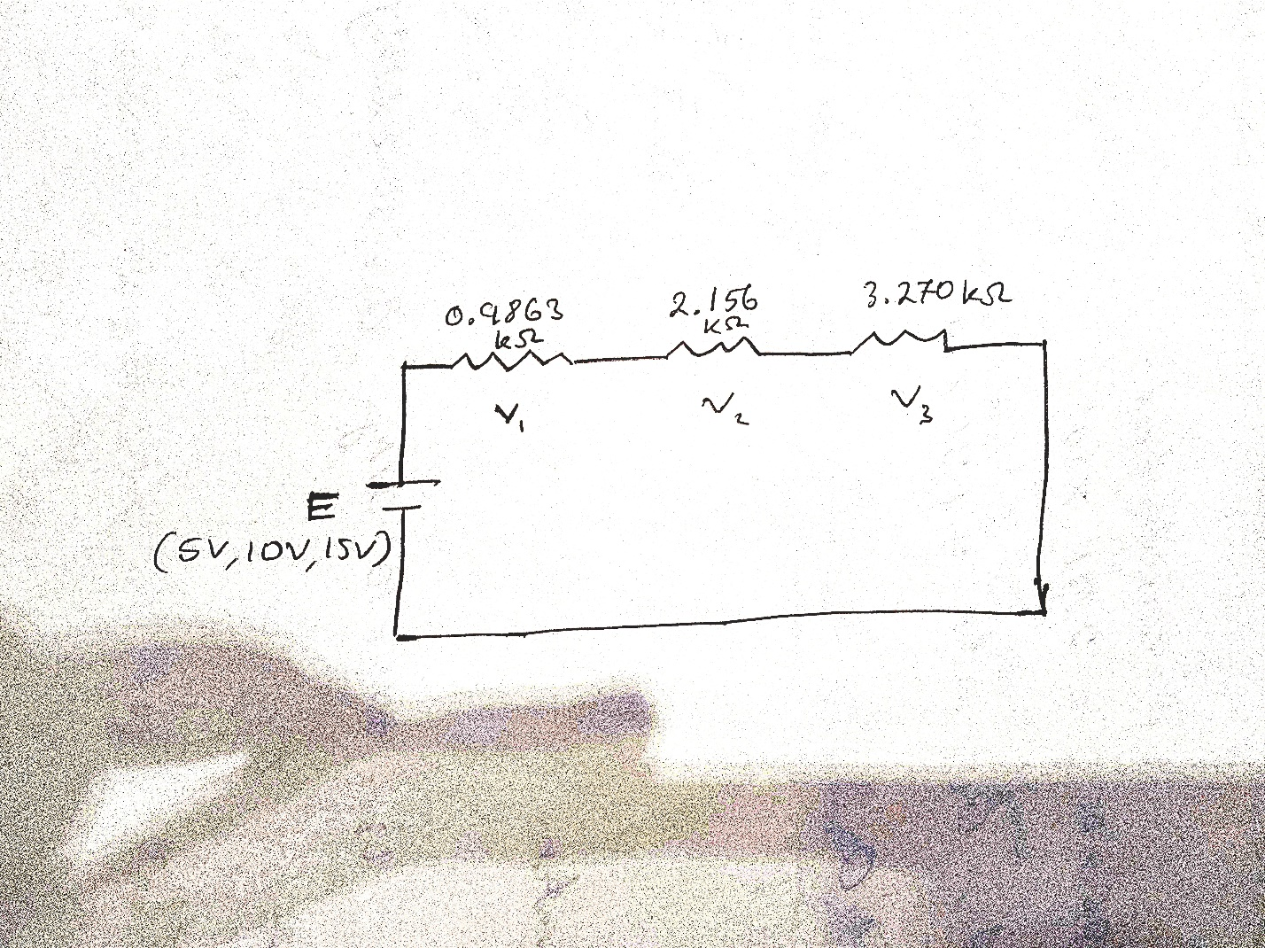

Diagram 1: Loop circuit

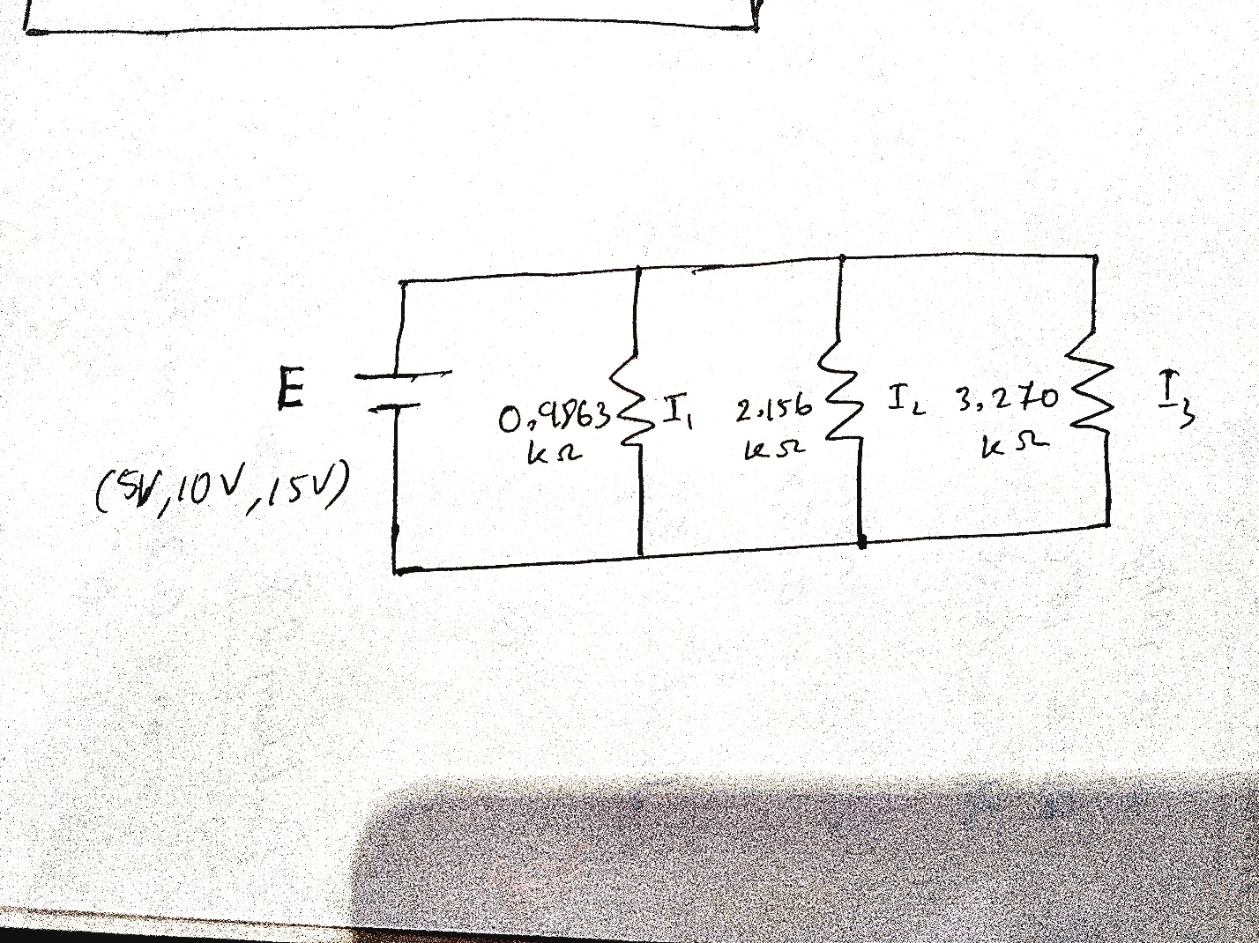

Diagram 2: Node circuit

***Experimental Data & Procedure:***

We connected the circuit in the breadboard as shown in the diagram 1, then the voltage across each element of the circuit was measured.

After that, we filled the following table with necessary calculations.

|  |  |  |  |  |  |  |  |  |  |  |  |  |  |  |
| --- | --- | --- | --- | --- | --- | --- | --- | --- | --- | --- | --- | --- | --- | --- |
| **No**  **Of**  **Obs.** | **R1**  **KΩ** | **R2**  **KΩ** | **R3**  **KΩ** | **Source Voltage**  **(v)** | | **Voltage across R1, V1** | | **Voltage across R2,**  **V2** | | **Voltage across R3,**  **V3** | | **Total Voltage Drop =**  **V1+V2+V3 (V)** | | **%Error**  **=%(mv**  **-cv) /CV** |
| **CV** | **MV** | **CV** | **MV** | **CV** | **MV** | **CV** | **MV** | **CV** | **MV** |
| **1** | 0.9863 | 2.156 | 3.270 | 5 | 5.052 | 0.769 | 0.7774 | 1.681 | 1.699 | 2.549 | 2.575 | 4.999 | 5.0517 | 1.05% |
| **2** | 0.9863 | 2.156 | 3.270 | 10 | 10.085 | 1.538 | 1.5518 | 3.3622 | 3.390 | 5.099 | 5.140 | 9.999 | 10.081 | 0.82% |
| **3** | 0.9863 | 2.156 | 3.270 | 15 | 15.090 | 2.307 | 2.321 | 5.043 | 5.073 | 7.649 | 7.690 | 14.99 | 15.084 | 0.62% |

# *TABLE-1*

Then we connected the circuit as shown in diagram 2. After that, the current across each branch or node of the circuit was measured. In the end, the following table was filled with necessary calculations.

***TABLE-2***

|  |  |  |  |  |  |  |  |  |  |  |  |  |  |  |  |  |  |
| --- | --- | --- | --- | --- | --- | --- | --- | --- | --- | --- | --- | --- | --- | --- | --- | --- | --- |
| **No**  **Of**  **Obs.** | **R1**  **KΩ** | **R2**  **KΩ** | **R3**  **KΩ** |  | **I** | |  | **I1** | | **I2** | |  | **I3** | | **I=I1+I2 +I3** | | **%Error =%(**  **mv-**  **cv) /CV** |
| **C  A** |  | **M  A** | **C  A** |  | **M A** | **C A** | **M A** | **C A** |  | **M A** | **C A** | **M A** |
| **1** | 0.9863 | 2.156 | 3.270 | 8.913 |  | 8.850 | 5.069 |  | 5.071 | 2.319 | 2.333 | 1.529 |  | 1.540 | 8.917 | 8.944 | 0.3% |
| **2** | 0.9863 | 2.156 | 3.270 | 17.83 |  | 17.42 | 10.14 |  | 10.22 | 4.638 | 4.613 | 3.058 |  | 3.043 | 17.836 | 17.876 | 0.22% |
| **3** | 0.9863 | 2.156 | 3.270 | 26.74 |  | 26.25 | 15.21 |  | 15.72 | 6.957 | 6.937 | 4.587 |  | 4.573 | 26.752 | 27.23 | 1.79% |

***Theoretical Calculation:***

**For KVL:**

Here, R1=0.9863 KΩ

R2= 2.156 KΩ

R3=3.270 KΩ

For, V = 5 V

RT=(0.9863+2.156+3.270)= 6.4123 KΩ

I = V/RT= 0.7797 V

V1 = IR1= (0.7797×0.9863)=0.769 V

V2 = IR2= (0.7797×2.156)=1.68 V

V3 = IR3= (0.7797×3.270)=2.549 V

For, V = 10 V

RT=(0.9863+2.156+3.270)= 6.4123 KΩ

I = V/RT= 1.559 V

V1 = IR1= (1.559 ×0.9863)= 1.538V

V2 = IR2= (1.559 ×2.156)= 3.3622V

V3 = IR3= (1.559 ×3.270)= 5.099V

For, V = 15 V

RT=(0.9863+2.156+3.270)= 6.4123 KΩ

I = V/RT= 2.339 mA

V1 = IR1= (2.339 ×0.9863)=2.30 V

V2 = IR2= (2.339 ×2.156)=5.04 V

V3 = IR3= (2.339 ×3.270)=7.64 V

**For KCL:**

Here, R1=0.9863 KΩ

R2= 2.156 KΩ

R3=3.270 KΩ

RT=(0.9863-1+2.156 -1+3.270 -1)-1= 0.561 KΩ

For 1st observation V1=5V,

I1=V/R1=(5/0.9863) =5.06 mA

I2=V/R2=(5/2.156) =2.31 mA

I3=V/R3=(5/3.270) =1.52 mA

When V=10 V,

I1=V/R1=(10/0.9863) =10.13 mA

I2=V/R2=(10/2.156) =4.63 mA

I3=V/R3=(10/3.270) =3.05 mA

When V=15 V,

I1=V/R1=(15/0.9863) =15.20 mA

I2=V/R2=(15/2.156) =6.95 mA

I3=V/R3=(15/3.270) =4.58 mA

***Simulation:***

***For KVL (table1):  
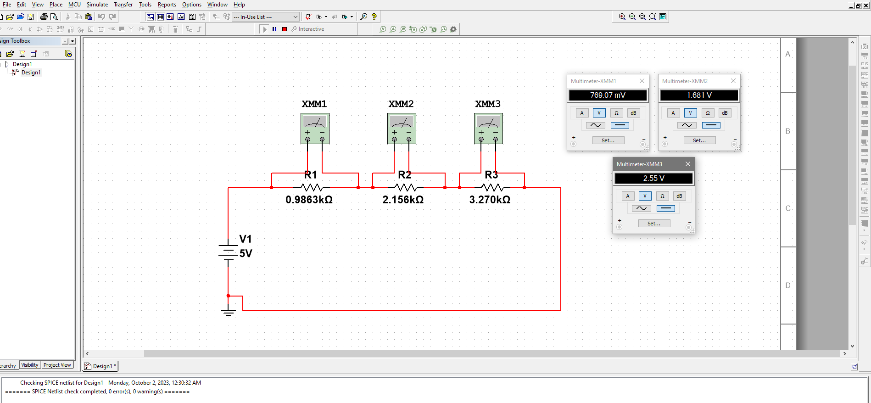***

Figure: When the V=5V, the multimeter reading for V1, V2 and V3.

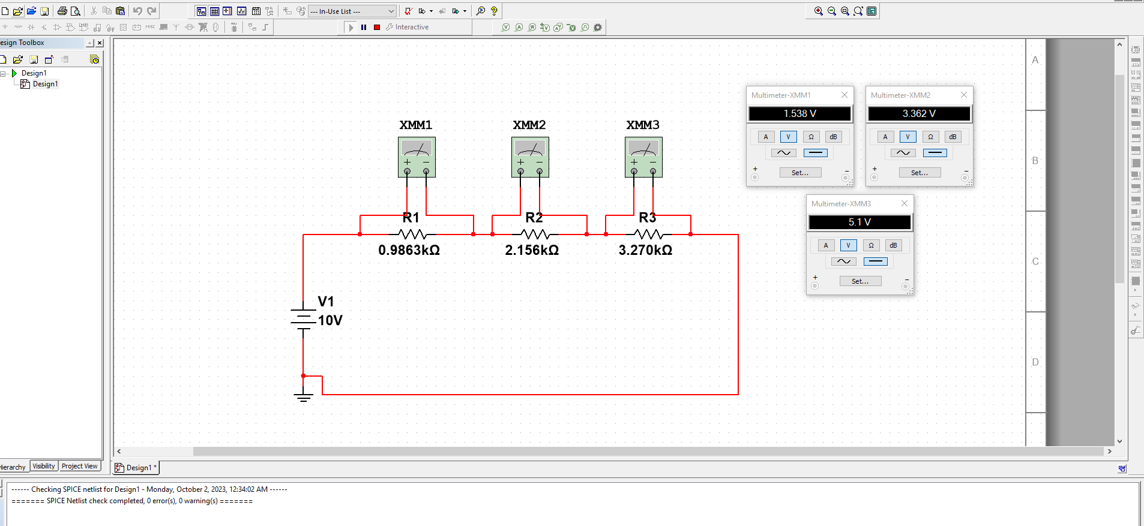

Figure: When the V=10V, the multimeter reading for V1, V2 and V3.

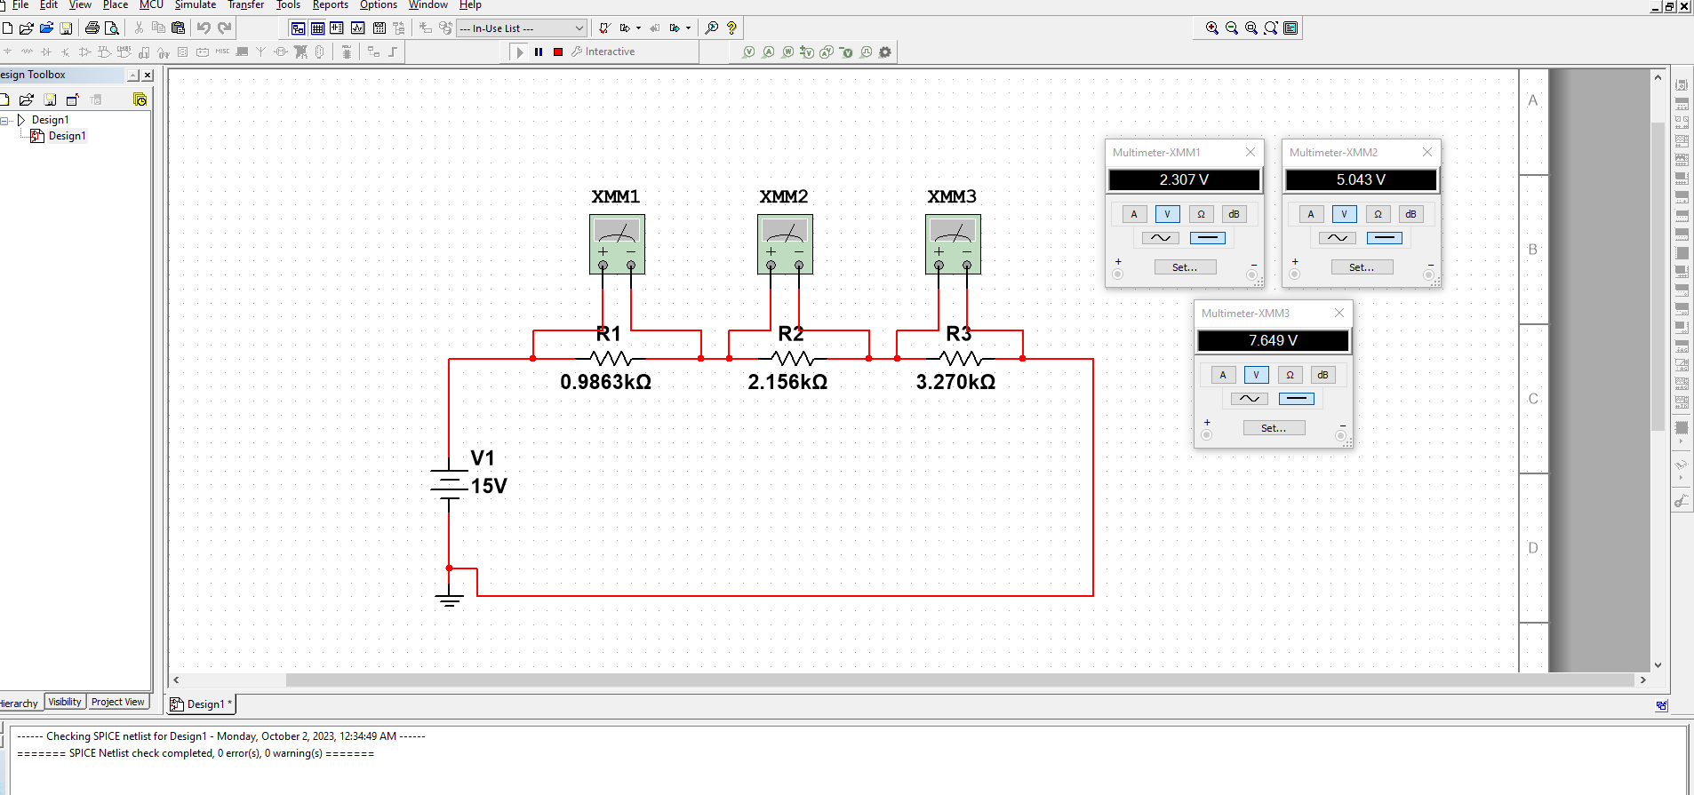

Figure: When the V=15V, the multimeter reading for V1, V2 and V3.

***For KCL (table2):***

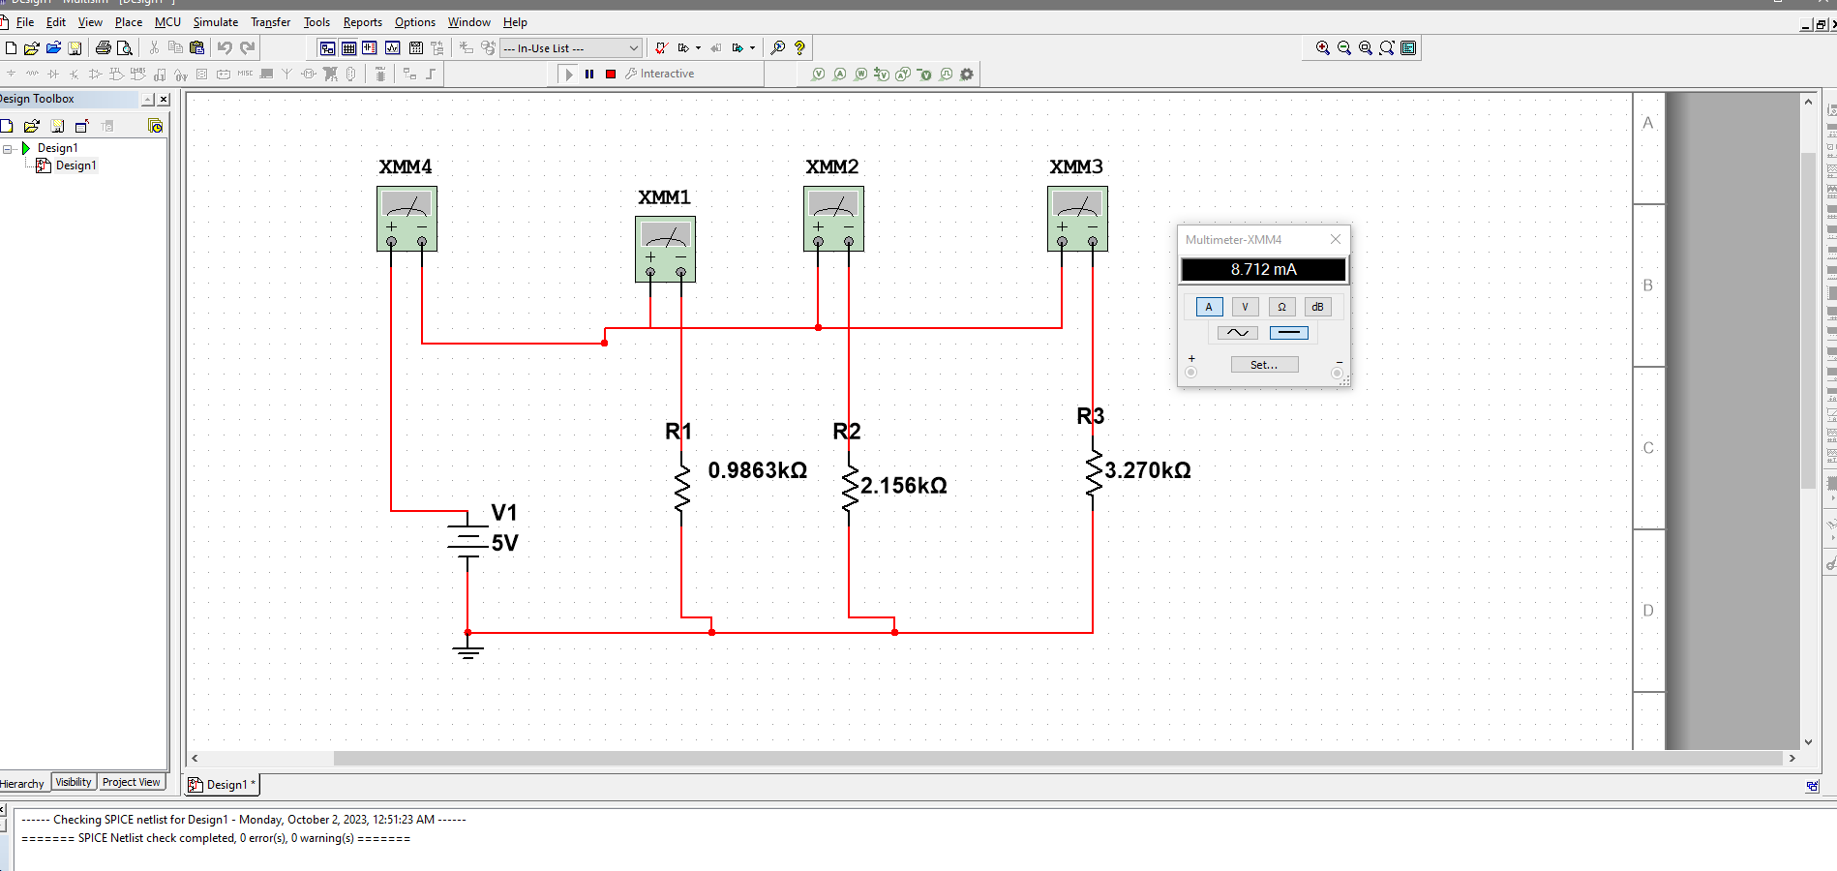

Figure: When the V=5V, the multimeter reading for Total Current I.

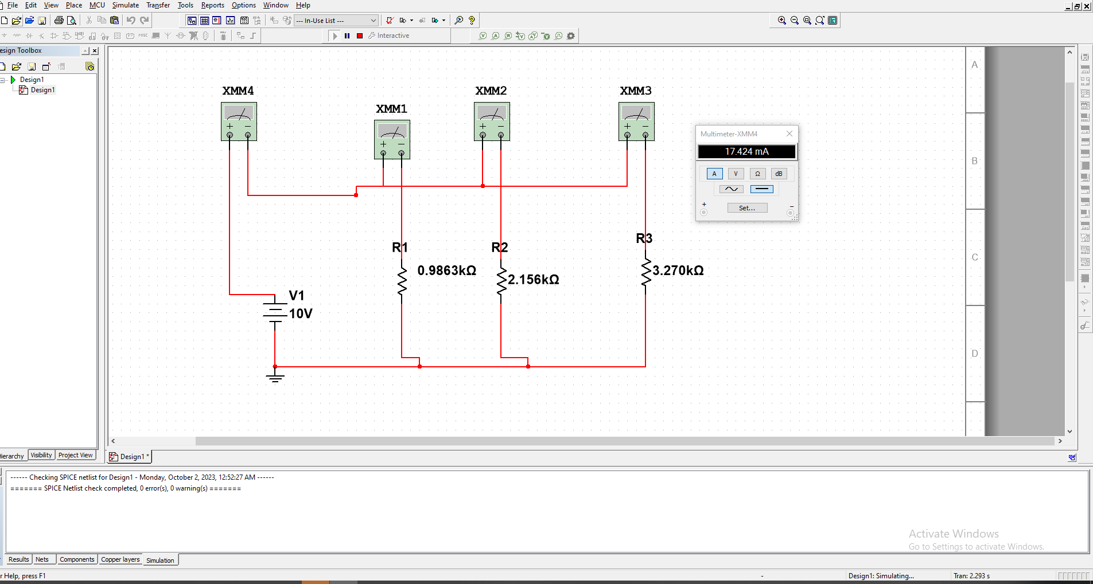

Figure: When the V=10V, the multimeter reading for Total Current I.

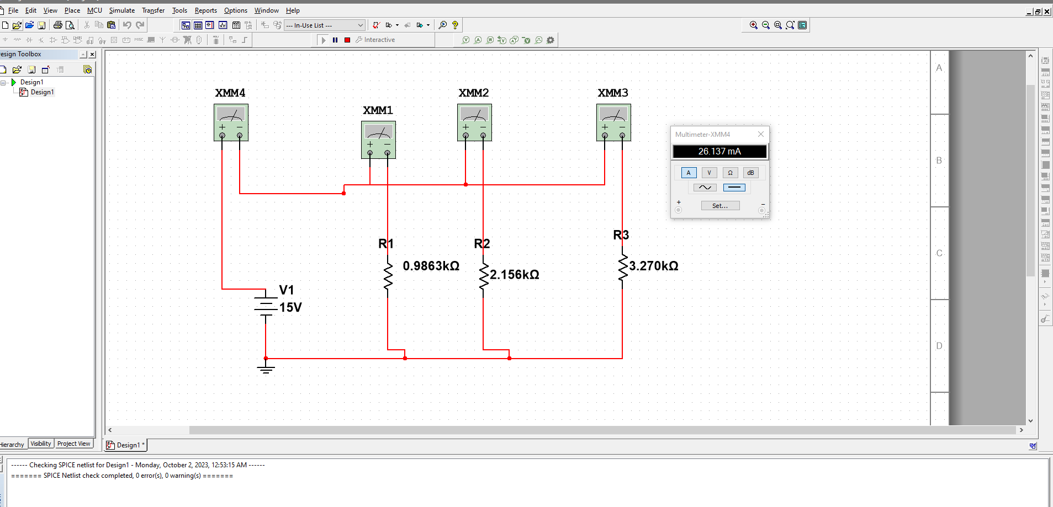

Figure: When the V=15V, the multimeter reading for Total Current I.

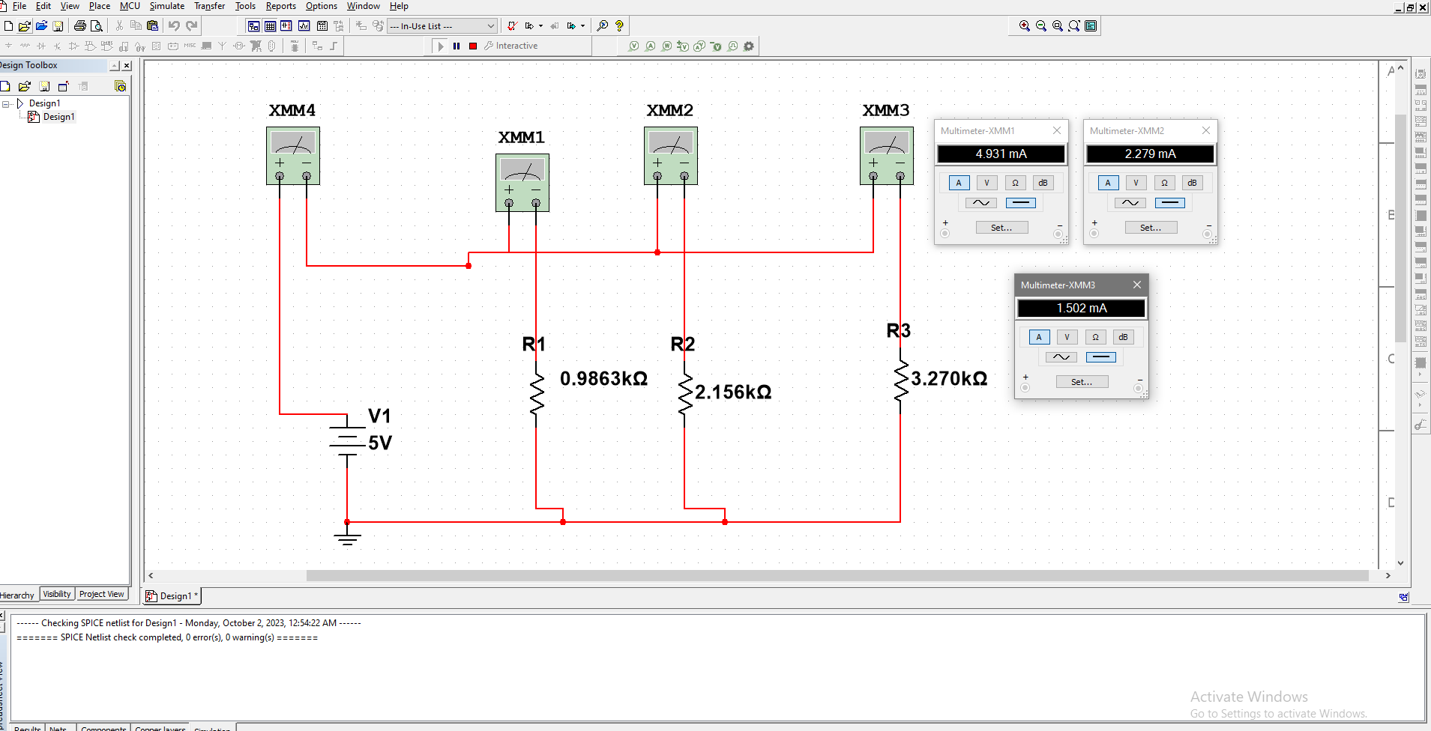

Figure: When the V=5V, the multimeter current reading for I1, I2 and I3.

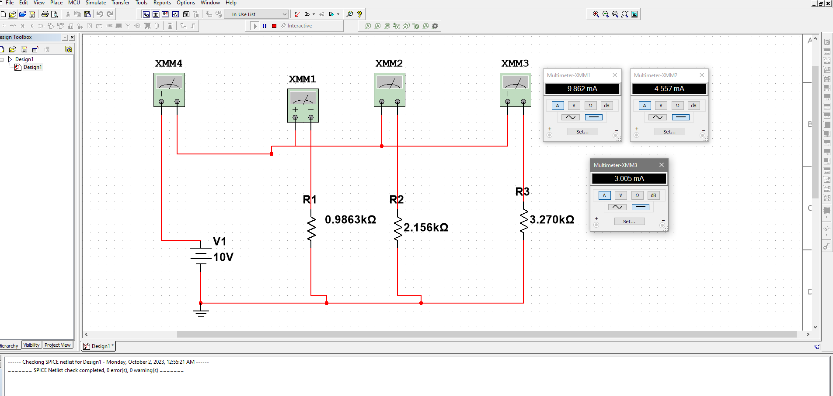

Figure: When the V=10V, the multimeter current reading for I1, I2 and I3.

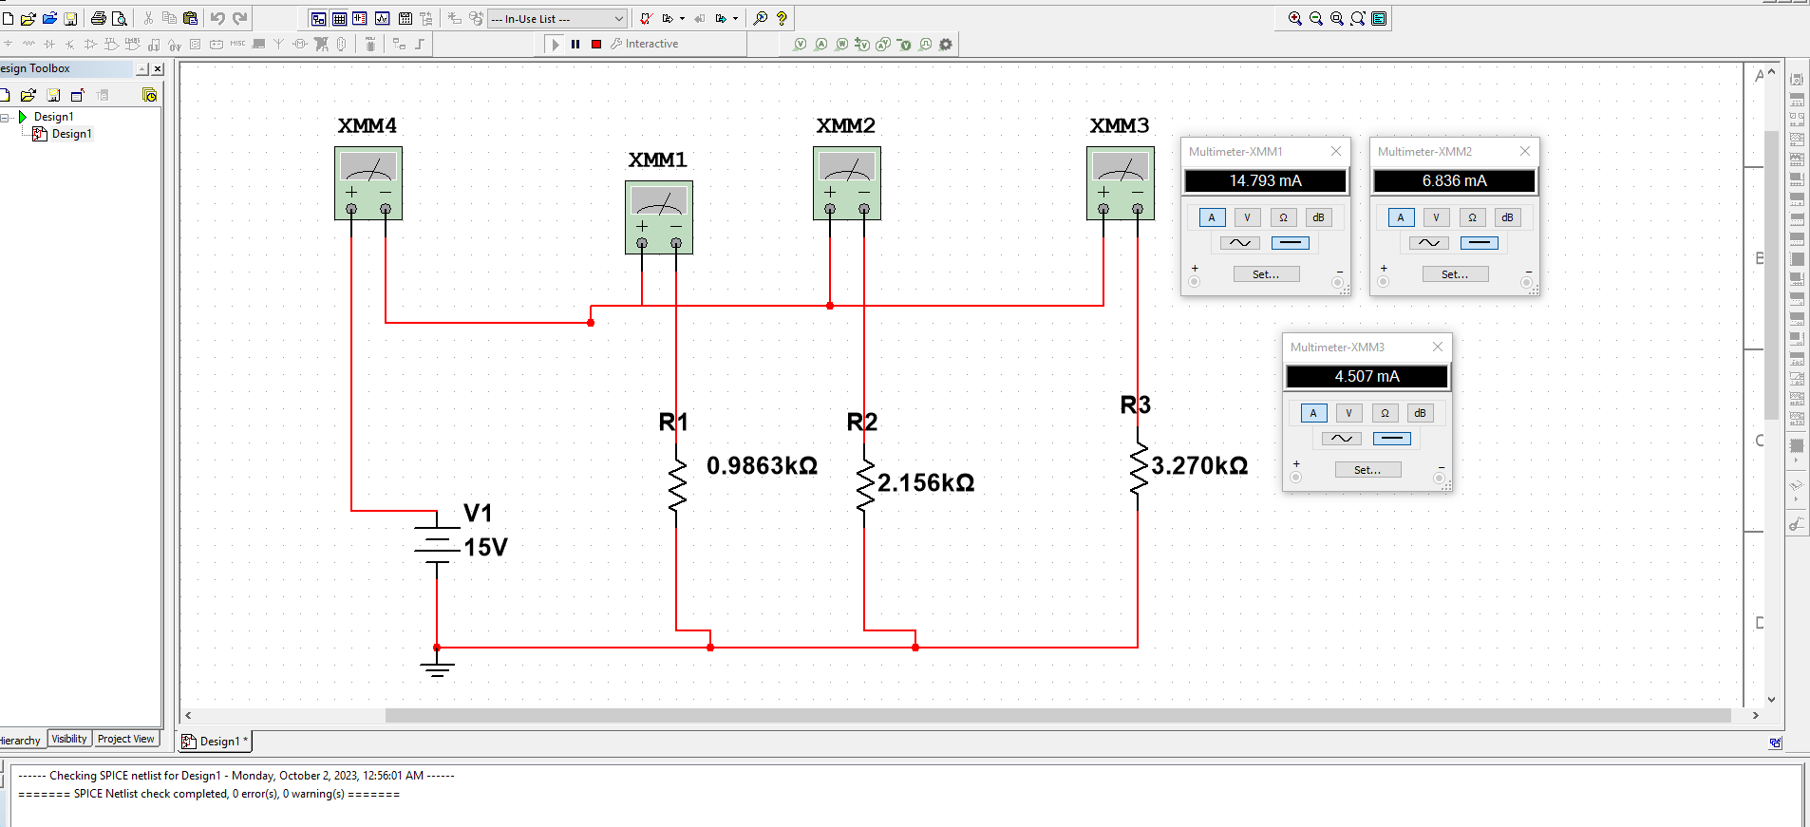

Figure: When the V=15V, the multimeter current reading for I1, I2 and I3.

***Discussion:***

In this experiment we created two circuits to verify KVL and KCL. In the 1st circuit we connected the circuit in a series connection and measured voltage using a multimeter across the resistors to satisfy KVL and in the 2nd circuit we connected it in a parallel connection and measured the current using a multimeter across the resistors to verify KCL. After we calculated our values for voltage in the series circuit, current in the parallel circuit respectively we found out, we do have some errors, it might be due to the human error while taking measurement, resistance in wires, temperature not being constant etc.

***Conclusion:***

Our results indicate that the calculated values and our measured values are quite similar to each other and the percentage error is less than 5% so we can say that it is in the accepted range and therefore our experiment was successful.